2.4 Problem 4

Build two classification trees using the iris sample dataset within the Orange application. Keep all parameters for both classifiers the same (Feature Selection,

Pruning), and modify the Limit Depth parameter to a smaller value than the default (e.g., from 10 to 2). How does this affect the Precision and Recall of the classifier? What types of flowers are misclassified? Why? What does Tan refer to as the border where these misclassifications occur?

**Answer:**

For the above problem, depth parameters where assumed as 3 and 10. As the depth increases the precision and recall decreases.

Iris-Versicolor and Iris-Verginica are misclassified. The flowers are misclassified as only the petal length and petal width are considered while classifying.

Tan refers to the border where these misclassifications occur as the decision boundary.

Depth=3

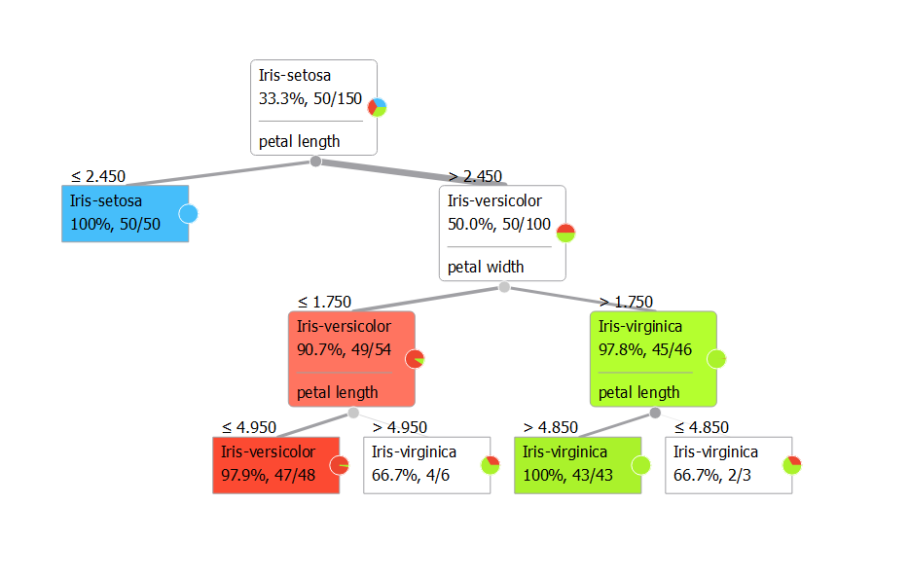

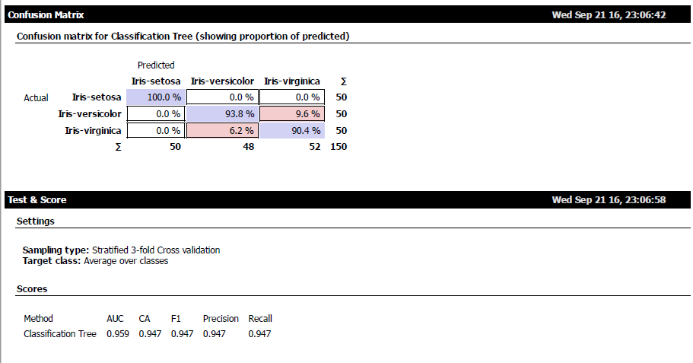

Depth=10

